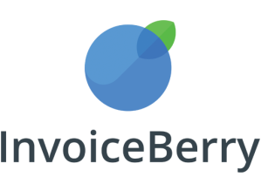  Blog Name  www.yourblog.com  35 Kingsland Road  London, E2 8AA, UK  hello@invoiceberry.com | INVOICE
Invoice #0073
Date: July 29, 2026

To:
Walter White
Blue Crystal Industries
124 Arizona Street
Albuquerque, NM
DESCRIPTION |  |  |  |  | QUANTITY | UNIT PRICE | TOTAL
Sponsored Blog Posts for June 16 and 23, 2017 |  |  |  | 2 |  | $75 | $150
 |  |  | SUBTOTAL |  |  |  | $150
 |  |  | SALES TAX (10%) |  |  |  | $15
 |  |  | TOTAL due |  |  |  | $165
Make all checks payable to [Your Company Name]. Payment is due within 15 days.
If you have any questions concerning this invoice, contact [Name, phone number, e-mail].

Thank you for your business!

